One-Sample t Test Example 4 (Commuter Students) – ANSWER KEY

Kennesaw State University has a large number of commuter students. The registrar wants to determine whether KSU students differ in the number of miles they drive to school compared to the national average (μ = 16).

Step 1. State your hypotheses.
a. Is it a one-tailed or two-tailed test?
Two-tailed

b. Research hypotheses
H_{A}: KSU students differ in the number of miles driven to school compared to the national average.

H₀: KSU students do not differ in the number of miles driven to school compared to the national average.

c. Statistical hypotheses
H_{A}: μ_{ksu} ≠ 16

H₀: μ_{ksu} = 16

Step 2. Set the significance level ➔ α = .05 Determine t_{crit}. t_{crit} = + 2.262

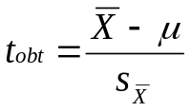Step 3. Select and compute the appropriate statistical test.
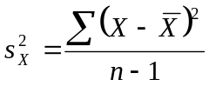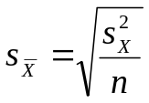
Miles Commuted  X |  | X – | (X –)²
10 | 10 | 0 | 0
5 |  | -5 | 25
22 |  | 12 | 144
4 |  | -6 | 36
15 |  | 5 | 25
5 |  | -5 | 25
7 |  | -3 | 9
9 |  | -1 | 1
3 |  | -7 | 49
20 |  | 10 | 100
ΣX = 100 |  |  | 414

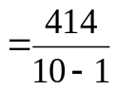
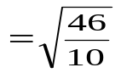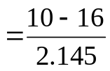

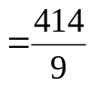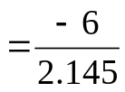
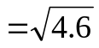

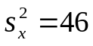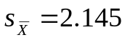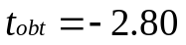

Step 4. Make a decision. Determine whether the value of the test statistic is in the critical region. Draw a picture. Label t_{crit} and t_{obt}.
Is t_{obt} in the critical region? Yes
Should you reject or retain the H₀? Reject
t_{obt} = -2.80

t_{crit} = -2.262 t_{crit} = +2.262

Step 5. Report the statistical results.

t(9) = -2.80, p < .05

Step 6. Write a conclusion.

KSU students (M=10) drive fewer miles to school than the national average (μ = 16).

Step 7. Compute the estimated d.
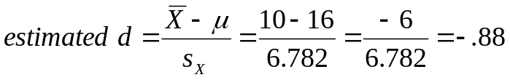

Step 8. Compute r² and write a conclusion.
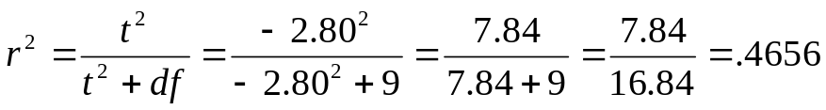

The fact that the sample consists of KSU students accounts for 47% of the variance in miles driven to school.

